NOVEMBER 2026 DEVOTIONAL
WALKING IN COURAGE
30 Days of Faithful Living and Bold Trust

The Historic St. James Missionary Baptist Church
The Year of Better: Rooted & Rising!
Love • Grow • Transform • Live

ST. JAMES FAMILY,
November invites us to move forward with courage rooted in God's promises. Courage is not the absence of fear. It is the decision to trust the Lord, make faithful choices, and continue even when the road feels uncertain.
This month, our devotionals will explore the courage to trust, obey, love, persevere, and prepare for what comes next. Each reading offers a Scripture, a practical step, and a prayer to help us live our faith in everyday moments.
As we continue through The Year of Better: Rooted & Rising!, may we remember that growing deeper roots gives us strength to rise. We do not need to know every answer to follow the One who leads us.
Walk in faith. Speak with love. Serve with courage. Trust God with each new step.

Grace and Peace,
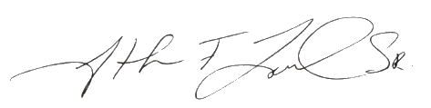
Pastor Jonathan F. Lowder, Sr.

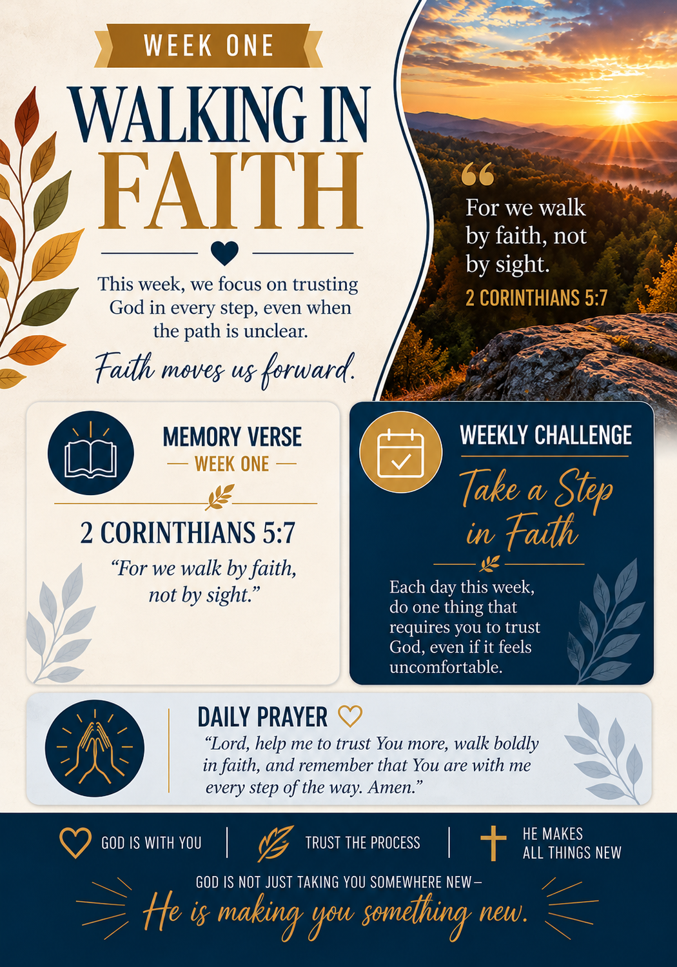
DAY 1: TRUST BEYOND WHAT YOU SEE
Heart Principle
Faith does not require every answer.
Scripture
2 Corinthians 5:7
Opening Reflection
Uncertainty can make us demand proof before moving. God invites us to walk with Him even when the whole road is not visible.
Biblical Insight
Paul describes the Christian life as walking by faith rather than sight.
Bridge to Daily Life
Pray about one situation you cannot fully predict.
Hope Principle
God is trustworthy beyond what I can see.
Daily Prayer Focus
Lord, strengthen my faith when answers are incomplete. Amen.
Reflection Question
Where am I demanding certainty before trusting God?
Today's Declaration
I will walk by faith today.

DAY 2: LET GO OF FEAR
Heart Principle
Fear need not make our decisions.
Scripture
Psalm 56:3
Opening Reflection
Fear often speaks loudly when the future feels unfamiliar. We can acknowledge it without giving it authority over our choices.
Biblical Insight
The psalmist responds to fear by placing trust in God.
Bridge to Daily Life
Name a fear and speak a prayer of trust over it.
Hope Principle
God hears me when I am afraid.
Daily Prayer Focus
Father, help me bring my fears to You. Amen.
Reflection Question
What fear has been guiding my actions?
Today's Declaration
Fear will not lead me today.

DAY 3: TAKE THE NEXT STEP
Heart Principle
Small steps of faith matter.
Scripture
Psalm 119:105
Opening Reflection
We sometimes wait for the entire plan to appear. Yet a lamp lights the next stretch of road, not every mile ahead.
Biblical Insight
God’s word is pictured as a lamp for our feet.
Bridge to Daily Life
Identify one responsible next step and take it.
Hope Principle
God provides direction for faithful living.
Daily Prayer Focus
Lord, illuminate the step before me. Amen.
Reflection Question
What step have I been delaying?
Today's Declaration
I will move forward with wisdom.

DAY 4: BE STILL ENOUGH TO LISTEN
Heart Principle
Listening is part of spiritual courage.
Scripture
1 Kings 19:12
Opening Reflection
Noise and urgency can make it difficult to hear what matters. Quiet attention creates room for prayerful discernment.
Biblical Insight
Elijah encountered God after wind, earthquake, and fire, in a gentle sound.
Bridge to Daily Life
Set aside ten minutes for silence and prayer.
Hope Principle
God meets us beyond the noise.
Daily Prayer Focus
God, quiet my heart and help me listen. Amen.
Reflection Question
What noise do I need to set aside?
Today's Declaration
I will make room to listen.

DAY 5: REMEMBER WHO GOES WITH YOU
Heart Principle
We do not face challenges alone.
Scripture
Deuteronomy 31:8
Opening Reflection
New responsibilities can make us feel unprepared. God’s presence is a deeper source of confidence than our own ability.
Biblical Insight
Moses assured Israel that the Lord would go before them.
Bridge to Daily Life
Begin a difficult task with a brief prayer.
Hope Principle
God does not abandon His people.
Daily Prayer Focus
Father, remind me of Your presence today. Amen.
Reflection Question
Where do I feel most alone?
Today's Declaration
God goes before me.

DAY 6: CHOOSE PEACEFUL TRUST
Heart Principle
Trust can steady an anxious heart.
Scripture
Isaiah 26:3
Opening Reflection
Our minds often rehearse possibilities that have not happened. Turning our attention to God helps us respond with steadiness.
Biblical Insight
Isaiah connects steadfast trust in God with peace.
Bridge to Daily Life
When worry rises, pause and pray before reacting.
Hope Principle
God can steady a troubled mind.
Daily Prayer Focus
Lord, anchor my thoughts in You. Amen.
Reflection Question
What thoughts need to be surrendered?
Today's Declaration
I will return my mind to God.

DAY 7: PRAY WITH EXPECTATION
Heart Principle
Prayer is a response of faith.
Scripture
Jeremiah 33:3
Opening Reflection
We may try every solution before bringing our concerns to God. Prayer is not our last resort; it is an invitation to relationship.
Biblical Insight
God called Jeremiah to seek Him in prayer.
Bridge to Daily Life
Bring one specific concern to God today.
Hope Principle
God invites us to call upon Him.
Daily Prayer Focus
Father, teach me to pray with openness and trust. Amen.
Reflection Question
What have I tried to handle without prayer?
Today's Declaration
I will seek God first.

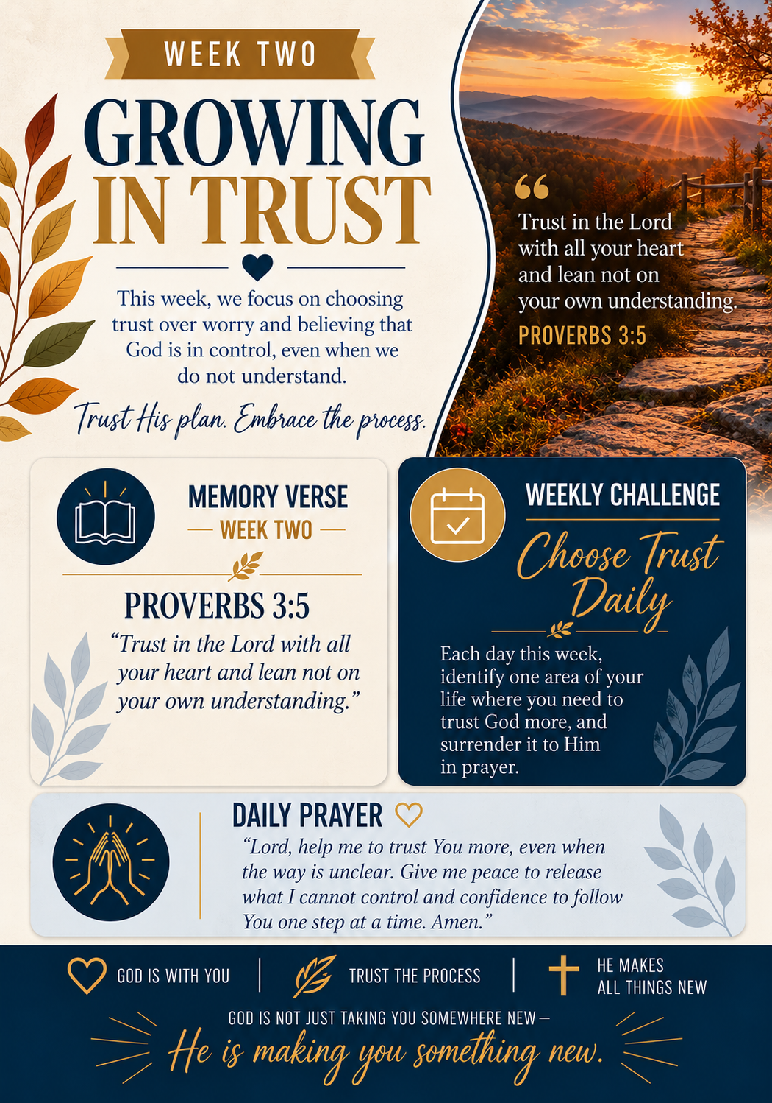
DAY 8: SAY YES TO GOD
Heart Principle
Obedience begins with willingness.
Scripture
Luke 1:38
Opening Reflection
A calling may interrupt the plans we carefully made. Like Mary, we can respond with humility even before we understand everything.
Biblical Insight
Mary received God’s message with willing faith.
Bridge to Daily Life
Ask God where you need a willing heart.
Hope Principle
God can work through humble obedience.
Daily Prayer Focus
Lord, make me willing to follow Your leading. Amen.
Reflection Question
Where am I resisting a needed yes?
Today's Declaration
My answer to God will be yes.

DAY 9: DO WHAT IS RIGHT
Heart Principle
Integrity matters when no one sees.
Scripture
Micah 6:8
Opening Reflection
Character is built in private decisions as much as public ones. Justice, mercy, and humility are everyday practices.
Biblical Insight
Micah calls God’s people to justice, mercy, and humble walking.
Bridge to Daily Life
Make one fair and honest choice even if unnoticed.
Hope Principle
Faithfulness is never wasted.
Daily Prayer Focus
Father, shape my choices with integrity. Amen.
Reflection Question
What would integrity require today?
Today's Declaration
I will choose what is right.

DAY 10: FOLLOW WITH HUMILITY
Heart Principle
We can learn while we lead.
Scripture
Philippians 2:3
Opening Reflection
Pride makes correction feel like defeat. Humility allows us to learn, apologize, and honor the contributions of others.
Biblical Insight
Paul urged believers to value others above selfish ambition.
Bridge to Daily Life
Invite feedback without becoming defensive.
Hope Principle
God gives grace for growth.
Daily Prayer Focus
Lord, keep my heart teachable. Amen.
Reflection Question
Where do I need greater humility?
Today's Declaration
I will lead with a teachable spirit.

DAY 11: USE WHAT YOU HAVE
Heart Principle
Faithfulness starts with what is in our hands.
Scripture
1 Peter 4:10
Opening Reflection
It is tempting to wait for better resources or a larger platform. God calls us to steward the gifts we already possess.
Biblical Insight
Peter teaches believers to serve with their varied gifts.
Bridge to Daily Life
Use one ability to help someone today.
Hope Principle
Every gift can serve a purpose.
Daily Prayer Focus
God, help me use what You entrusted to me. Amen.
Reflection Question
What gift have I been neglecting?
Today's Declaration
I will serve with what I have.

DAY 12: SPEAK THE TRUTH IN LOVE
Heart Principle
Courage and kindness belong together.
Scripture
Ephesians 4:15
Opening Reflection
Avoiding hard conversations may preserve comfort but not understanding. We can be truthful without being harsh.
Biblical Insight
Paul connects truthfulness with love and spiritual maturity.
Bridge to Daily Life
Have one honest, respectful conversation.
Hope Principle
Love can guide difficult words.
Daily Prayer Focus
Lord, give me wisdom and gentleness in speech. Amen.
Reflection Question
What truth needs a loving voice?
Today's Declaration
I will speak with truth and grace.

DAY 13: BE FAITHFUL IN LITTLE THINGS
Heart Principle
Consistency prepares us for greater trust.
Scripture
Luke 16:10
Opening Reflection
Ordinary tasks can feel unimportant. Yet faithfulness is often proven in small responsibilities handled with care.
Biblical Insight
Jesus taught that faithfulness in little matters is meaningful.
Bridge to Daily Life
Complete one overlooked responsibility well.
Hope Principle
God sees steady obedience.
Daily Prayer Focus
Father, help me honor You in small duties. Amen.
Reflection Question
What small task needs my attention?
Today's Declaration
I will be faithful in little things.

DAY 14: LET YOUR LIGHT SHINE
Heart Principle
Our actions can point others to God.
Scripture
Matthew 5:16
Opening Reflection
People notice how we respond to setbacks and how we treat those around us. A life of service can communicate hope without seeking attention.
Biblical Insight
Jesus calls His followers to shine through good works.
Bridge to Daily Life
Do one helpful act without expecting praise.
Hope Principle
Kindness can reflect God’s love.
Daily Prayer Focus
Jesus, let my actions honor You. Amen.
Reflection Question
What do my actions communicate?
Today's Declaration
I will reflect Christ today.

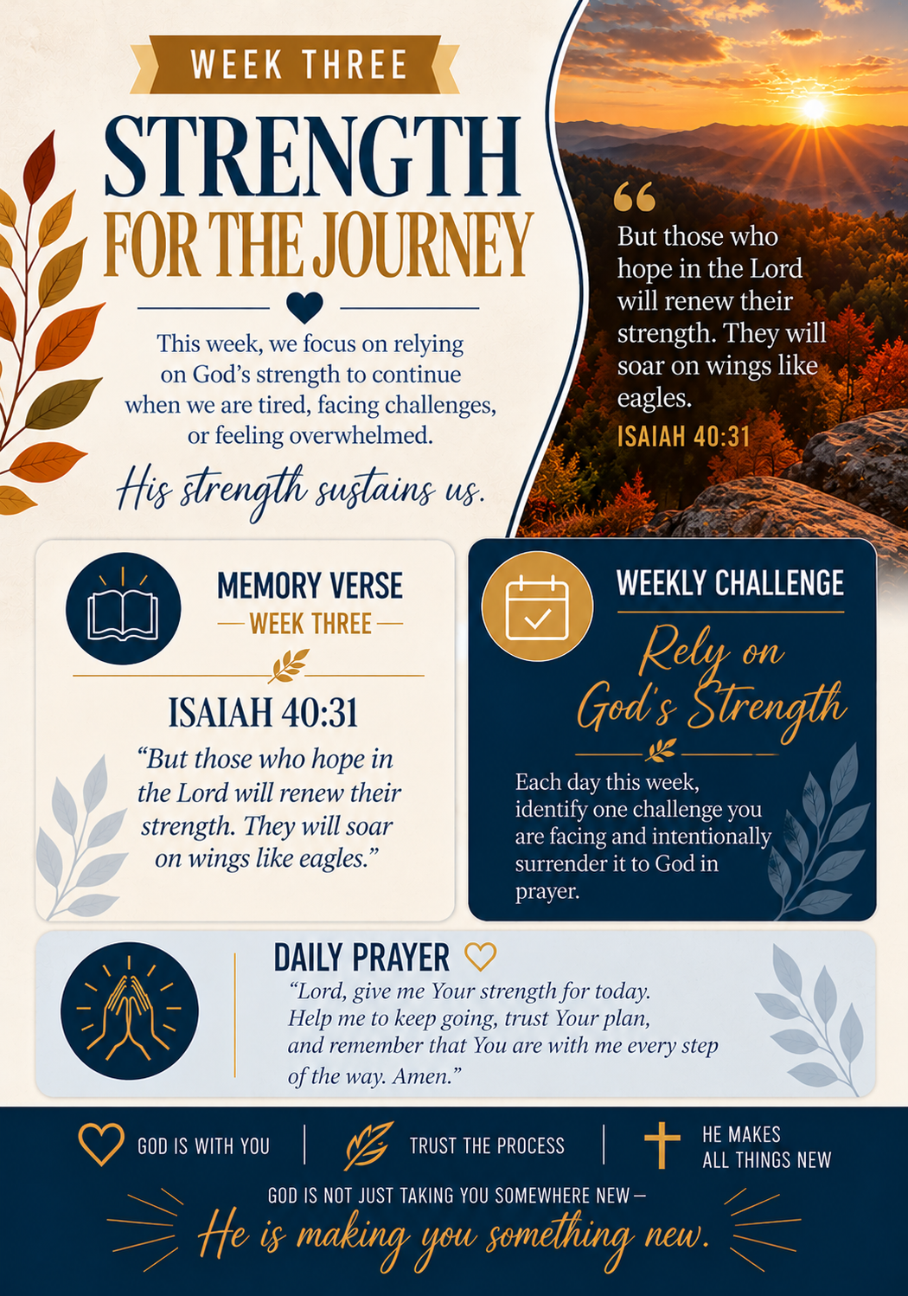
DAY 15: LOVE WITHOUT KEEPING SCORE
Heart Principle
Love is not a competition.
Scripture
1 Corinthians 13:5
Opening Reflection
Relationships suffer when every gesture becomes a tally. Christlike love looks for opportunities to care rather than reasons to withdraw.
Biblical Insight
Paul describes love as refusing to keep a record of wrongs.
Bridge to Daily Life
Offer kindness without demanding an immediate return.
Hope Principle
Love can break cycles of resentment.
Daily Prayer Focus
Lord, teach me generous love. Amen.
Reflection Question
Where have I been keeping score?
Today's Declaration
I will love without keeping score.

DAY 16: MAKE ROOM FOR FORGIVENESS
Heart Principle
Forgiveness opens a path away from bitterness.
Scripture
Colossians 3:13
Opening Reflection
Holding tightly to an offense can keep a wound at the center of our lives. Forgiveness is a process that can coexist with wise boundaries.
Biblical Insight
Paul calls believers to forgive as the Lord forgave them.
Bridge to Daily Life
Pray about a hurt you are ready to begin releasing.
Hope Principle
God can help heal wounded hearts.
Daily Prayer Focus
Father, guide me toward forgiveness and wisdom. Amen.
Reflection Question
What hurt am I carrying?
Today's Declaration
I will pursue forgiveness with wisdom.

DAY 17: NOTICE THE OVERLOOKED
Heart Principle
Every person deserves dignity.
Scripture
James 2:1
Opening Reflection
It is easy to give our attention to those with influence while missing someone who needs to be seen. God calls us beyond favoritism.
Biblical Insight
James warns believers against showing partiality.
Bridge to Daily Life
Include or encourage someone who is often overlooked.
Hope Principle
Every person bears worth before God.
Daily Prayer Focus
Lord, help me see others with compassion. Amen.
Reflection Question
Who might feel unseen around me?
Today's Declaration
I will treat people with dignity.

DAY 18: LISTEN BEFORE ANSWERING
Heart Principle
Understanding begins with patience.
Scripture
James 1:19
Opening Reflection
We can listen merely to prepare our reply. Genuine listening makes space for another person’s experience and can prevent needless conflict.
Biblical Insight
James urges believers to be quick to listen and slow to speak.
Bridge to Daily Life
Let someone finish before you respond.
Hope Principle
Patient listening can restore understanding.
Daily Prayer Focus
Father, teach me to listen with care. Amen.
Reflection Question
Do I listen to understand or to respond?
Today's Declaration
I will listen with patience.

DAY 19: BE A PEACEMAKER
Heart Principle
Peace takes courage and wisdom.
Scripture
Matthew 5:9
Opening Reflection
Avoiding conflict is not always the same as making peace. Peacemaking may require honesty, accountability, and a gentle spirit.
Biblical Insight
Jesus calls peacemakers blessed.
Bridge to Daily Life
Take one constructive step toward resolving tension.
Hope Principle
God can work through peaceful choices.
Daily Prayer Focus
Lord, make me an instrument of peace. Amen.
Reflection Question
Where can I help reduce tension?
Today's Declaration
I will seek peace with courage.

DAY 20: CARRY ONE ANOTHER
Heart Principle
Community is strengthened through care.
Scripture
Galatians 6:2
Opening Reflection
Everyone has seasons when a burden feels too heavy. Practical support can remind someone they do not have to face everything alone.
Biblical Insight
Paul calls believers to bear one another’s burdens.
Bridge to Daily Life
Check on someone and offer specific help.
Hope Principle
Shared care reflects Christ’s love.
Daily Prayer Focus
Father, make me attentive to others’ needs. Amen.
Reflection Question
Whose burden can I help lighten?
Today's Declaration
I will make room to help.

DAY 21: GIVE WITH JOY
Heart Principle
Generosity is more than money.
Scripture
2 Corinthians 9:7
Opening Reflection
Our time, attention, skills, and resources can all become gifts. Giving freely reminds us that love is meant to move outward.
Biblical Insight
Paul emphasizes willing and cheerful giving.
Bridge to Daily Life
Share something useful with a cheerful heart.
Hope Principle
God can use generous hearts.
Daily Prayer Focus
Lord, free me to give with joy. Amen.
Reflection Question
How can I practice generosity today?
Today's Declaration
I will give with a willing heart.
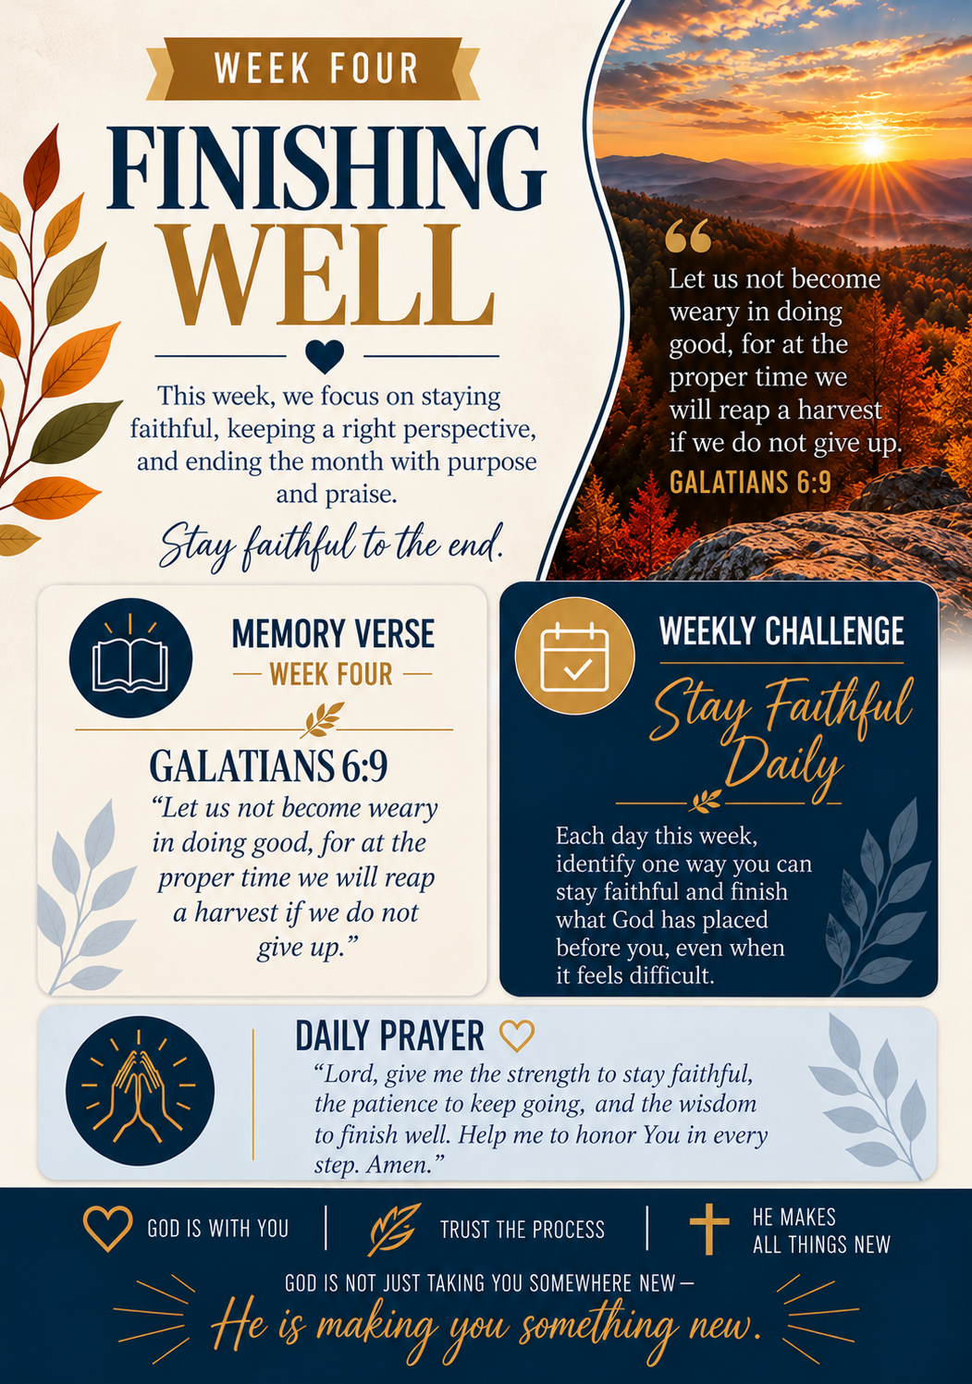
DAY 22: KEEP GOING IN FAITH
Heart Principle
Weariness does not erase purpose.
Scripture
Hebrews 12:1
Opening Reflection
Long seasons can test our patience. Instead of measuring ourselves against others, we can continue the race set before us.
Biblical Insight
Hebrews encourages believers to run with endurance.
Bridge to Daily Life
Choose one manageable step toward a worthwhile goal.
Hope Principle
Endurance grows through faithful steps.
Daily Prayer Focus
God, renew my perseverance. Amen.
Reflection Question
What has made me want to quit?
Today's Declaration
I will keep moving faithfully.

DAY 23: RISE AFTER A SETBACK
Heart Principle
A stumble is not the end.
Scripture
Proverbs 24:16
Opening Reflection
Mistakes and disappointments can leave us discouraged. Wisdom means learning what we can and getting back up with God’s help.
Biblical Insight
Proverbs portrays the righteous as rising after falling.
Bridge to Daily Life
Identify one lesson from a recent setback.
Hope Principle
God can help us begin again.
Daily Prayer Focus
Father, give me courage to rise again. Amen.
Reflection Question
What setback have I allowed to define me?
Today's Declaration
I will rise and continue.

DAY 24: STAND FIRM IN HOPE
Heart Principle
Hope has an anchor.
Scripture
Hebrews 6:19
Opening Reflection
Circumstances may shift without warning, but our hope in God need not be tossed about with every change.
Biblical Insight
Hebrews describes hope as an anchor for the soul.
Bridge to Daily Life
Write a promise from Scripture and revisit it.
Hope Principle
Hope in God gives stability.
Daily Prayer Focus
Lord, anchor my heart in Your promises. Amen.
Reflection Question
Where do I need steadier hope?
Today's Declaration
My hope is anchored in God.

DAY 25: WAIT WITHOUT GIVING UP
Heart Principle
Patience can be active faith.
Scripture
Romans 12:12
Opening Reflection
Waiting is not always inactivity. We can keep praying, preparing, and serving while trusting God with timing.
Biblical Insight
Paul joins hope, patience in trouble, and faithful prayer.
Bridge to Daily Life
Use a waiting season for one meaningful action.
Hope Principle
God can shape us in the meantime.
Daily Prayer Focus
Father, strengthen my patience and purpose. Amen.
Reflection Question
How can I be faithful while waiting?
Today's Declaration
I will wait with purpose.

DAY 26: FIND STRENGTH TO CONTINUE
Heart Principle
God meets us in weakness.
Scripture
2 Corinthians 12:9
Opening Reflection
We often feel pressured to appear strong. Admitting our limitations can open us to God’s grace and the support of others.
Biblical Insight
Paul learned that Christ’s power is made perfect in weakness.
Bridge to Daily Life
Ask for help in one area where you need support.
Hope Principle
God’s grace is sufficient for today.
Daily Prayer Focus
Jesus, meet me where I am weak. Amen.
Reflection Question
Where do I need to accept help?
Today's Declaration
His grace will sustain me.

DAY 27: KEEP YOUR EYES ON CHRIST
Heart Principle
Focus helps us endure.
Scripture
Hebrews 12:2
Opening Reflection
Distractions and comparisons can pull our attention away from our calling. Looking to Jesus restores our perspective.
Biblical Insight
Hebrews directs believers to Jesus as the pioneer and perfecter of faith.
Bridge to Daily Life
Limit one distraction during your prayer time.
Hope Principle
Christ is worthy of our attention.
Daily Prayer Focus
Lord, refocus my heart on You. Amen.
Reflection Question
What has distracted me from my purpose?
Today's Declaration
I will fix my eyes on Jesus.

DAY 28: FINISH WITH FAITHFULNESS
Heart Principle
How we finish matters.
Scripture
2 Timothy 4:7
Opening Reflection
Finishing well does not mean doing everything perfectly. It means remaining committed to what God has placed before us.
Biblical Insight
Paul reflects on having kept the faith through his journey.
Bridge to Daily Life
Finish one commitment you have been postponing.
Hope Principle
Faithful effort has lasting value.
Daily Prayer Focus
Father, help me finish this season well. Amen.
Reflection Question
What needs my faithful attention?
Today's Declaration
I will finish with faith.

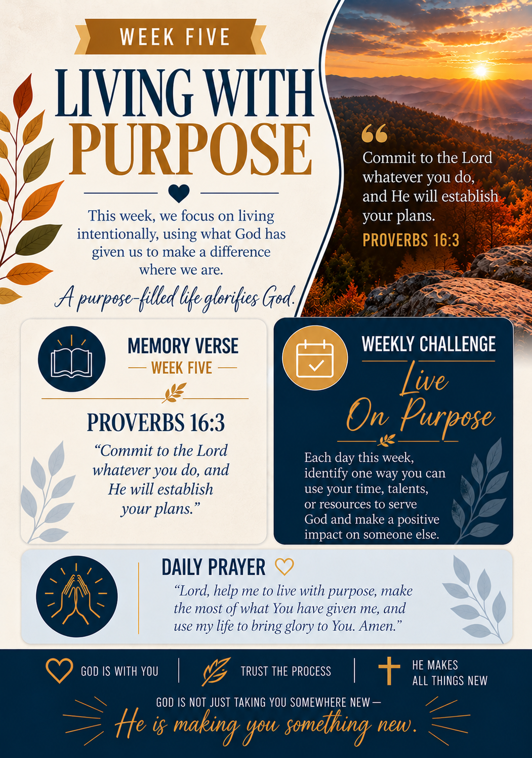
DAY 29: COMMIT YOUR PLANS
Heart Principle
Planning and surrender can work together.
Scripture
Proverbs 16:3
Opening Reflection
A new month invites fresh plans. We can prepare responsibly while holding our expectations with open hands before God.
Biblical Insight
Proverbs encourages entrusting our work to the Lord.
Bridge to Daily Life
Pray over your priorities for the coming month.
Hope Principle
God can guide our plans.
Daily Prayer Focus
Lord, direct the work of my hands. Amen.
Reflection Question
What plans do I need to commit to God?
Today's Declaration
I will plan prayerfully.

DAY 30: STEP INTO THE NEW SEASON
Heart Principle
God remains faithful through change.
Scripture
Isaiah 43:19
Opening Reflection
As November closes, we can welcome what lies ahead without pretending we know every detail. The same God who led us this far remains with us.
Biblical Insight
Isaiah announces God’s power to make a new way.
Bridge to Daily Life
Name one lesson to carry into December.
Hope Principle
God is present in every new beginning.
Daily Prayer Focus
Father, prepare my heart for what comes next. Amen.
Reflection Question
What will I carry into the next season?
Today's Declaration
I will enter the new season with faith.
MONTH-END BLESSING
St. James Family,
As November comes to a close, may courage remain part of our daily walk with God. May we trust Him in uncertainty, follow Him in obedience, and love others with sincerity.
Remember that courage can be quiet: a prayer before a difficult conversation, a kind response when patience is tested, or another faithful step after disappointment.
As we continue through The Year of Better: Rooted & Rising!, may the Lord deepen our faith and strengthen our commitment to Love, Grow, Transform, and Live for His glory.
May God give you wisdom for your decisions, endurance for your responsibilities, peace for your heart, and hope for the season ahead.
The Historic St. James Missionary Baptist Church
The Year of Better: Rooted & Rising!

Pastor Jonathan F. Lowder, Sr.





